Assessment: *Assigment1*

Student Name:

Lab Professor Name:

Lab Section Number:

Due Date:

1)Under stand the problem:

a program to be coded to do math equation to input three numbers x , y and z and calculate the sum of them and use the sum of them (x+y+z) and divide by three( sum/3) to get the average and calculate square root of them (√sum) , raise x to the power of y (x^z) ,raise y to the power of z (y^z) , raise z to the power of x (z^x) and print them to the screen and print the my full name (Zahi Masarwa)

2) pseudo-code:

Start

Declare Double x,y,z,sum, squareroot,power1on2,power2on3,power3on1,avrage

Output “Program to run Math equation”

Output “Please Enter First number between 1-10:”

Input x

Output “Please Enter Second number between 1-10:”

Input y

Output “Please Enter third number between 1-10:”

Input z

Sum=the sum of x,y and z

Average=the average of x,y,z

Squareroot=the square root of x ,y and z

power1on2=x to the power of y

power2on3=y to the power of z

power3on1=z to the power of x

output “first number is:x, second number is:y ,third number is:y”

Output “"The sum of numbers enterned:"+sum”

Output “"The Average of the three numbers is: Average”

Output “The Square root of the three number is: Squareroot”

Output “x to the power of y is: power1on2”

Output “y to the power of z is: power2on3”

Output “z to the power of x is: power3on1”

Output “my full name”

End

Flowchart:

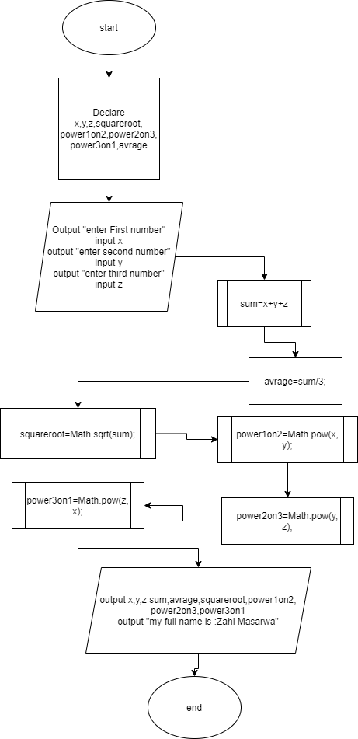

4)Test algorithm

|  |  |  |  |
| --- | --- | --- | --- |
| Input | Expected outputs | Actual outputs (Algorithm) | Description |
| 2,3,4 | 2,3,4  Sum=9  Average =3  Square root=3  2^3=8  3^4=81  4^2=16 | Sum=9  Average =3  Square root=3  2^3=8  3^4=81  4^2=16 |  |

5)

a) Compile and Run Your Program

import java.util.Scanner;

import java.lang.Math;

public class Calculate {

public static void main(String[] args) {

double x,y,z,sum,squareroot,power1on2,power2on3,power3on1,avrage;

Scanner Keyboard= new Scanner(System.in);

System.out.println("Program to run Math equation");

System.out.println("Please Enter First number between 1-10:");

x=Keyboard.nextDouble();

System.out.println("Please Enter Second number between 1-10:");

y=Keyboard.nextDouble();

System.out.println("Please Enter Third number between 1-10:");

z=Keyboard.nextDouble();

Keyboard.close();

sum=x+y+z;

avrage=sum/3;

squareroot=Math.sqrt(sum);

power1on2=Math.pow(x, y);

power2on3=Math.pow(y, z);

power3on1=Math.pow(z, x);

System.out.println("first number is:"+x+", second number is:"+y+" ,third number is:"+z);

System.out.println("The sum of numbers enterned"+sum+"\n");

System.out.println("The Average of the three numbers is:"+avrage);

System.out.println("The Square root of the three number is:"+squareroot);

System.out.println(x+" to the power of "+y+"is: "+power1on2);

System.out.println(y+" to the power of "+z+"is: "+power2on3);

System.out.println(z+" to the power of "+x+"is: "+power3on1);

System.out.println("My Full Name is: ");

}

}

5b) Test Your Program

|  |  |  |  |
| --- | --- | --- | --- |
| Input | Expected outputs | Actual outputs (Algorithm) | Description |
| 2,3,4 | The Average of the three numbers is:3.0  The Square root of the three number is:3.0  2.0 to the power of 3.0is: 8.0  3.0 to the power of 4.0is: 81.0  4.0 to the power of 2.0is: 16.0  My Full Name is: Zahi Masarwa | The Average of the three numbers is:3.0  The Square root of the three number is:3.0  2.0 to the power of 3.0is: 8.0  3.0 to the power of 4.0is: 81.0  4.0 to the power of 2.0is: 16.0  My Full Name is: Zahi Masarwa |  |
| 2,3,a | Error | Exception in thread "main" java.util.InputMismatchException  at java.base/java.util.Scanner.throwFor(Scanner.java:939)  at java.base/java.util.Scanner.next(Scanner.java:1594)  at java.base/java.util.Scanner.nextDouble(Scanner.java:2564)  at Calculate.main(Calculate.java:25) | Error code since I entered string |